P 3 Redistribution Between RIP and OSPF
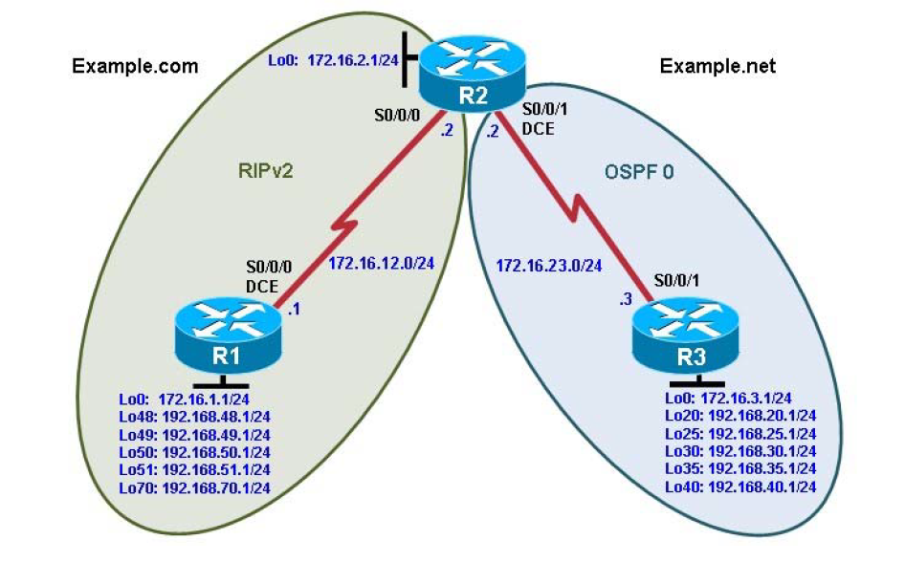

Background:
Two online booksellers, Example.com and Example.net, have merged and now need a short-term solution to inter-domain routing. Since these companies provide client services to Internet users, it is essential to have minimal downtime during the transition.

Example.com is a small firm running RIP, while Example.net has a somewhat larger network running OSPF. The diagram identifies R2 as the router that will bridge the two networks. Because it is imperative that the two
booksellers continuously deliver Internet services, you should bridge these two routing domains without interfering with each router’s path through its own routing domain to the Internet.

The CIO determines that it is preferable to keep the two protocol domains shown in the diagram during the transition period, because the network engineers on each side need to understand the other’s network before deploying a long-term solution. Redistribution will be a short-term solution.

Objectives
• Review configuration and verification of RIP and OSPF.
• Configure passive interfaces in both RIP and OSPF.
• Filter routing updates using distribute lists.
• Redistribute static routes into RIP.
• Redistribute RIP routes into OSPF.
• Redistribute OSPF routes into RIP.
• Originate a default route into OSPF.

Step 1: Configure loopbacks and assign addresses.

R1(config)# interface Loopback0
R1(config-if)# ip address 172.16.1.1 255.255.255.0
R1(config-if)# interface Loopback48
R1(config-if)# ip address 192.168.48.1 255.255.255.0
R1(config-if)# interface Loopback49
R1(config-if)# ip address 192.168.49.1 255.255.255.0
R1(config-if)# interface Loopback50
R1(config-if)# ip address 192.168.50.1 255.255.255.0
R1(config-if)# interface Loopback51
R1(config-if)# ip address 192.168.51.1 255.255.255.0
R1(config-if)# interface Loopback70
R1(config-if)# ip address 192.168.70.1 255.255.255.0
R1(config-if)# interface Serial0/0/0
R1(config-if)# ip address 172.16.12.1 255.255.255.0
R1(config-if)# clock rate 64000
R1(config-if)# bandwidth 64
R1(config-if)# no shutdown

R2(config)# interface Loopback0
R2(config-if)# ip address 172.16.2.1 255.255.255.0
R2(config-if)# interface Serial0/0/0
R2(config-if)# ip address 172.16.12.2 255.255.255.0
R2(config-if)# bandwidth 64
R2(config-if)# no shutdown
R2(config-if)# interface Serial0/0/1
R2(config-if)# ip address 172.16.23.2 255.255.255.0
R2(config-if)# clock rate 64000
R2(config-if)# bandwidth 64
R2(config-if)# no shutdown

R3(config)# interface Loopback0
R3(config-if)# ip address 172.16.3.1 255.255.255.0
R3(config-if)# interface Loopback20
R3(config-if)# ip address 192.168.20.1 255.255.255.0
R3(config-if)# interface Loopback25
R3(config-if)# ip address 192.168.25.1 255.255.255.0
R3(config-if)# interface Loopback30
R3(config-if)# ip address 192.168.30.1 255.255.255.0
R3(config-if)# interface Loopback35
R3(config-if)# ip address 192.168.35.1 255.255.255.0
R3(config-if)# interface Loopback40
R3(config-if)# ip address 192.168.40.1 255.255.255.0
R3(config-if)# interface Serial0/0/1
R3(config-if)# ip address 172.16.23.3 255.255.255.0
R3(config-if)# bandwidth 64
R3(config-if)# no shutdown

Step 2: Configure RIPv2.

R1(config)# router rip
R1(config-router)# version 2
R1(config-router)# no auto-summary
R1(config-router)# network 172.16.0.0
R1(config-router)# network 192.168.48.0
R1(config-router)# network 192.168.49.0
R1(config-router)# network 192.168.50.0
R1(config-router)# network 192.168.51.0
R1(config-router)# network 192.168.70.0

R2(config)# router rip
R2(config-router)# version 2
R2(config-router)# no auto-summary
R2(config-router)# network 172.16.0.0

R1# show ip route rip
R2# show ip route rip

Step 3: Configure passive interfaces in RIP.

R1# show ip route rip
R2(config)# router rip
R2(config-router)# passive-interface serial 0/0/1
R2# show ip protocols

R1(config)# router rip
R1(config-router)# passive-interface loopback 0
R1(config-router)# passive-interface loopback 48
R1(config-router)# passive-interface loopback 49
R1(config-router)# passive-interface loopback 50
R1(config-router)# passive-interface loopback 51
R1(config-router)# passive-interface loopback 70
R2(config)# router rip
R2(config-router)# passive-interface loopback 0

Step 4: Summarize a supernet with RIP.

R2# show ip route rip
R1(config)# ip route 192.168.48.0 255.255.252.0 null0
R1(config)# router rip
R1(config-router)# redistribute static
R1# show ip route
R2# show ip route

Step 5: Suppress routes using prefix lists.

R1(config)# ip prefix-list RIP-OUT permit 192.168.48.0/22
R1(config)# ip prefix-list RIP-OUT deny 192.168.48.0/22 le 24
R1(config)# ip prefix-list RIP-OUT permit 0.0.0.0/0 le 32

R1(config)# router rip
R1(config-router)# distribute-list prefix RIP-OUT out serial0/0/0

R2# show ip route rip
R2# show ip rip database

Step 6: Configure OSPF.

R2(config)# router ospf 1
R2(config-router)# network 172.16.23.0 0.0.0.255 area 0
R3(config)# router ospf 1
R3(config-router)# network 172.16.0.0 0.0.255.255 area 0
R3(config-router)# network 192.168.0.0 0.0.255.255 area 0

R3(config)# interface Loopback0
R3(config-if)# ip ospf network point-to-point
R3(config-if)# interface Loopback20
R3(config-if)# ip ospf network point-to-point
R3(config-if)# nterface Loopback25
R3(config-if)# ip ospf network point-to-point
R3(config-if)# interface Loopback30
R3(config-if)# ip ospf network point-to-point
R3(config-if)# interface Loopback35
R3(config-if)# ip ospf network point-to-point
R3(config-if)# interface Loopback40
R3(config-if)# ip ospf network point-to-point

R3# show ip ospf neighbor
R2# show ip route ospf
R3# show ip route ospf

Step 7: Configure passive interfaces in OSPF.

R3(config)# router ospf 1
R3(config-router)# passive-interface default
R3(config-router)# no passive-interface serial 0/0/1
R3# how ip protocols

Step 8: Allow one-way redistribution.

R2(config)# router rip
R2(config-router)# redistribute ospf 1 metric 4
R2# show ip protocols
R1# show ip route rip
R1# ping 192.168.30.1
R1# traceroute 192.168.30.1
R2(config)# router ospf 1
R2(config-router)# default-information originate always

Step 9: Redistribute between two routing protocols.

R2(config)# router ospf 1
R2(config-router)# no default-information originate always
R2(config-router)# redistribute rip
R3# show ip route ospf
R2(config)# router ospf 1
R2(config-router)# redistribute rip subnets
R3# show ip route ospf

